**Practical No.3**

**Name**: Anuj Rajendra Mane

**Div**: SY A

**Roll No**: 65 **Batch**: A3

**PRN** **No**: 2162701242054

##### Title: Program on Control Statements (for, while, do-while)

* **Theory of for Loop**

Loops are used to execute a set of statements repeatedly until a particular condition is satisfied. In Java we have three types of basic loops: for, while and do-while. In this tutorial we will learn how to use “for loop” in Java.

**Example:   
 Software of the ATM machine** is in a loop to process transaction after transaction until you acknowledge that you have no more to do. Software program in a mobile device allows user to unlock the mobile with 5 password attempts.

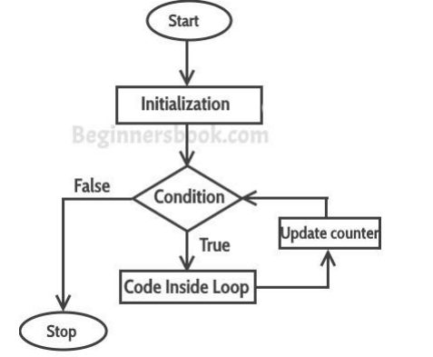

**Syntax of for loop:**

for(initialization; condition ; increment/decrement)

{

statement(s);

}

**Flow of Execution of the for Loop**

As a program executes, the interpreter always keeps track of which statement is about to be executed. We call this the control flow, or the flow of execution of the program.

**Example of Simple For loop**

class ForLoopExample {

public static void main(String args[]) {

for (int i = 10; i > 1; i--) {

System.out.println("The value of i is: " + i);

}

}

}

**Output:**

* 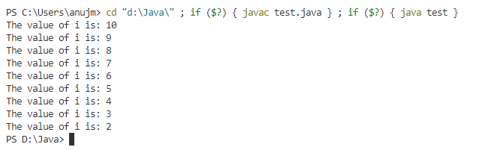**While loop in Java**

In the last tutorial, we discussed for loop. In this tutorial we will discuss while loop. As discussed in previous tutorial, loops are used to execute a set of statements repeatedly until a particular condition is satisfied.

**Example:**

When you want to surf channel in TV you must minimum watch 1 channel in TV and then The conditions ‘While' say that if you bored you can do surf channel (it will stop if you not bored).

**Syntax of while loop**

while(condition){

statement(s);

}

**How while Loop works?**

In while loop, condition is evaluated first and if it returns true then the statements inside while loop execute. When condition returns false, the control comes out of loop and jumps to the next statement after while loop. Note: The important point to note when using while loop is that we need to use increment or decrement statement inside while loop so that the loop variable gets changed on each iteration, and at some point condition returns false. This way we can end the execution of while loop otherwise the loop would execute indefinitely.

**Simple while loop example**

class WhileLoopExample {

public static void main(String args[]) {

int i = 10;

while (i > 1) {

System.out.print(i+” “);

i--;

}

}

}

**Output:**



* **do-while loop in Java with example**

In the last tutorial, we discussed while loop. In this tutorial we will discuss do-while loop in java. do-while loop is similar to while loop, however there is a difference between them: In while loop, condition is evaluated before the execution of loop’s body but in do-while loop condition is evaluated after the execution of loop’s body.

**Example**:

So consider the case of a cash dispenser, an ATM. In this case, you are first required to enter your PIN number, i.e. the body of the loop, before the PIN number is validated, i.e. the loop’s condition.

If validation fails, the loop iterates again and you re-enter your PIN number (up until a certain number of times), otherwise, the loop exits

**Syntax of do-while loop:**

do {

statement(s);

} while(condition);

**How do-while loop works?**

First, the statements inside loop execute and then the condition gets evaluated, if the condition returns true then the control gets transferred to the “do” else it jumps to the next statement after do-while.

**do-while loop example**

class DoWhileLoopExample {

public static void main(String args[]) {

int i = 10;

do {

System.out.print(i+” “);

i--;

} while (i > 1);

}

}

**Output**:



* **Switch Statement In java:**

Switch statement allows us to execute one statement from many statement and the statements are called case.

Inside the body of switch there are a number of cases and there is a single number is passed at the place of parameter to select and execute a case.

**Syntax**:

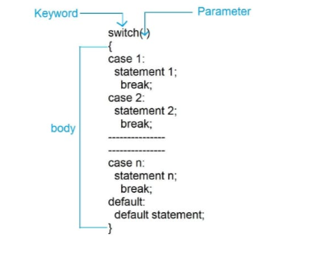

**Program**:

class Easy

{

public static void main(String[] args)

{

int day=2;

switch(day)

{

case 1:

System.out.println("Monday");

break;

case 2:

System.out.println("Tuesday");

break;

case 3:

System.out.println("Wednesday");

break;

case 4:

System.out.println("Thrusday");

break;

case 5:

System.out.println("Friday");

break;

case 6:

System.out.println("Saturday");

break;

case 7:

System.out.println("Sunday");

break;

default:

System.out.println("No case matched");

}

}

}



**Break Statement in java:**

It is used to transfer the control out of the body of loop.

In other word we can say that it terminates the current loop.

break statement are mostly used with loop(for,while,do while) and switch statement.

**Program**:

class Easy

{

public static void main(String[] args)

{

for(int i=1;i<=10;i++)

{

System.out.print(i+" ");

if(i==5)//terminate the loop when i=5

break;

}

}

}

**Output:**

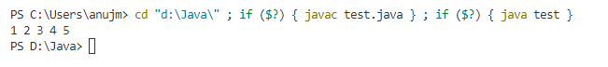

**Continue statement:**

It is used to skip the next statement and continue the loop.

continue statement are mostly used with loop(for,while,do while).

**Program:**

class Easy

{

public static void main(String[] args)

{

for(int i=1;i<=5;i++)

{

if(i==3)//skip the next statement when i=3

continue;

else

System.out.print(i+" ");

}

}

}



**Conclusion:**

I can learn the concepts of control statements of for loop, Do while, Switch Case Break, Break , Continue And also doing some programmes.

**Completion Date: Co-Ordinator Sign:**